
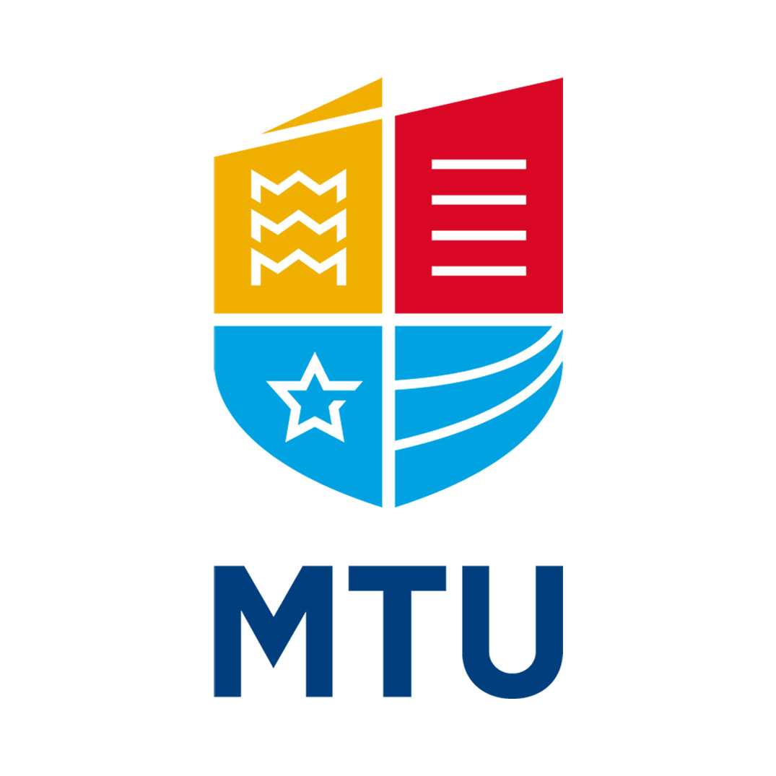

Preparing Your Business for the Solar Eclipse
12 August 2026
On Wednesday 12 August 2026, Cork and Kerry will experience one of the most significant astronomical events visible from Ireland for decades. Approximately 95% of the Sun will be obscured by the Moon, with the eclipse taking place low on the western horizon. It will start at 6pm, conclude at 8pm and the maximum coverage of the Sun will occur shortly after 7.15 pm.
Cork will be the best-placed city in Ireland from which to view the event. Kerry will be the best-paced county.
If you can see the setting sun towards the west, you can see the eclipse. It’s that simple!
There will likely be a large amount of coverage in the local, national, and international media. There will not be another eclipse with this level of interest until 2090.
Why It Matters for your business
Unlike most astronomical events, this eclipse occurs at a convenient evening hour and will be experienced by people across Cork-Kerry simultaneously. The event creates a potentially unique opportunity for your business to take advantage of the interest and excitement around the eclipse without the need for any specialist equipment or knowledge.
Businesses that acknowledge the event can benefit from increased visibility, stronger customer engagement, and positive community association with one of the signature city or regional events of 2026.
How to get involved
Find out all you need to know about eclipse watching and at the same time make your event visible by completing a simple, free registration form on https://www.bco.ie/solar-eclipse/. Registration is not mandatory, but for those businesses who do register their event we will provide 20 eclipse glasses free for use.
Thousands of people are expected to gather at viewpoints across Cork and Kerry, from back gardens to businesses. At MTU Blackrock Castle Observatory, with support from the Nighttime Economy initiative and the Dept. of Culture, Communications & Sport, we will host public observing sessions, an eclipse exhibition and family activities. Simple ideas can be the best! Be creative.
Examples of Business Opportunities (you may have your own ideas!)

Restaurants, Cafés and Bars
• Develop eclipse-themed food and drink specials in the days leading up to the event.
• Offer opening hours until 8pm on the eclipse evening.
• Create viewing menus or make use of outdoor seating for customers which faces the direction of the setting Sun.

Retail
• Create eye-catching eclipse window displays.
• Run one-day promotions or limited-edition products.

Hotels and Tourism
• Promote 'Experience the Eclipse in Cork/Kerry' packages.
• Highlight nearby scenic viewing locations.
• Partner with local attractions including MTU Blackrock Castle Observatory to register and highlight your event.

Arts, Culture and Entertainment
• Host astronomy-themed talks or performances.
• Promote the 'Inspired by the Eclipse' photography competition being coordinated by MTU Blackrock Castle Observatory and capture images on the evening, whether it’s clear or cloudy! It could be as simple as raising a toast at 7:15pm to mark the maximum of the eclipse.
• Cross-promote with MTU Blackrock Castle Observatory activities by registering your event, however simple, or sophisticated it might be.

Marketing and Media
• Run countdown campaigns on social media.
• Celebrate customers and communities experiencing the eclipse together.
• Use the event to reinforce local pride and civic participation.

Transport
• Consider additional evening services or promotions to popular viewing sites.

